**Total Aggregations using SQL Queries:**

**AVG():**

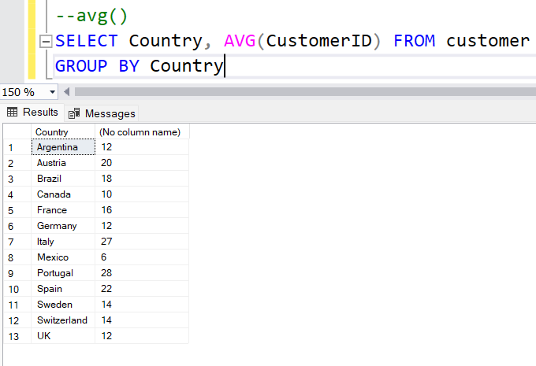

**COUNT():**

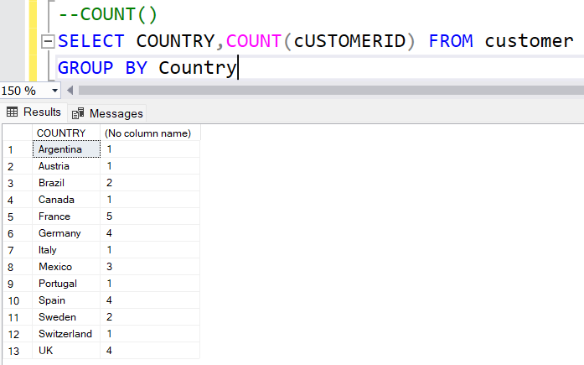

**DISTINCT():**

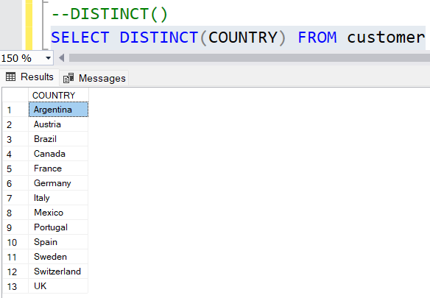

**MAX():**

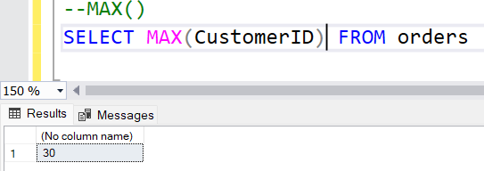

**MIN():**

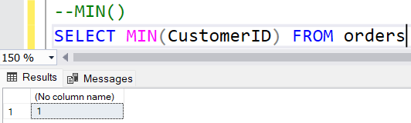

**SUM():**

